Addendum to
“The P-band Radiometer Inferred Soil Moisture Experiment 2021
WORKPLAN”

Xiaoling Wu, Nan Ye, Jeff Walker, Foad Brakhasi, Luisa White Murillo

April 2021

CONTENT
CONTENT II
1. SUMMARY 1
2. FLIGHT OBSERVATIONS 1
3. CALIBRATION TARGETS 2
4. TEMPORARY MONITORING STATIONS 3
5. GROUND SOIL MOISTURE SAMPLING 5
6. SCOUT SAMPLING 7
7. ROUGHNESS SAMPLING 8
8. VEGETATION SAMPLING AND INTENSIVE VEGETATION SAMPLING 10
9. SAMPLES PROCESSING IN LAB 11
10. LAKE SAMPLING 11
11. ATTACHMENT-FLIGHT NOTEBOOK 11

SUMMARY
This document contains the addendum to the PRISM-2021 experiment workplan. Any aspect not mentioned here is to be assumed unchanged from the original document.
The PRISM-2021 experiment was conducted from 8-26 March, 2021. Airborne flights were conducted with concurrent ground sampling occurring on all days. Airborne radiometer data (at L- and P-band) were collected three times per week (9 flights in total) while the radar data (at L- and P-band) were collected twice per week (6 flights in total). Airborne spectral measurements (FLIR, NDVI and RGB images) were acquired on some days during the campaign. Some raining events were experienced in the study area during the campaign. This led to changes on the flight schedule (See Table 2-1) as well as on the ground sampling schedule (See Table 5-1). Also, the farming activities including machinery ploughing and irrigation have resulted in changes on the sampling areas (See Table 5-2).

FLIGHT OBSERVATIONS
Airborne monitoring was undertaken largely as outlined in the experiment workplan, with the exception of some dates that were switched due to poor weather (raining events). The updated schedule for the scientific flights is shown in Table 2-1. Changes with respect to Table 4-1 from the workplan are highlighted in bold characters.
Table 2-1. PRISM-2021 flights schedule (MA-Multiangular radiometer flight; MR-Multifrequncy radar flight). Changes with respect to Table 4-1 from the workplan are highlighted in bold blue characters.
Date | Flight | Observations | Note  (Issue)
08/03 | F1-MA | PPMR, PLMR, FLIR, NDVI, RGB | Cloudy/high cloud
09/03 | F2-MR | PLIS, PPIS860, PPIS440, FLIR, NDVI, RGB | -
10/03 | F3-MA | PPMR, PLMR, FLIR, NDVI, RGB | -
11/03 | F4-MR | PLIS, PPIS860, PPIS440, FLIR, NDVI, RGB | No radar flight due to rain
12/03 | F4-MA | PPMR, PLMR, FLIR, NDVI, RGB | -
15/03 | F5-MA | PPMR, PLMR, FLIR, NDVI, RGB | -
16/03 | F6-MR | PLIS, PPIS860, PPIS440, FLIR, NDVI | Clear sky; RGB camera didn’t work.
17/03 | F7-MA | PPMR, PLMR, FLIR, NDVI, RGB | -
18/03 | F8-MR | PLIS, PPIS860, PPIS440, FLIR, NDVI | Cloudy; RGB camera did not work.
19/03 | F9-MA | PPMR, PLMR, FLIR, NDVI, RGB | -
22/03 | F10-MA | PPMR, PLMR, FLIR, NDVI, RGB | Flight cancelled due to heavy rain
23/03 | F10-MA | PPMR | No calibration done; only done PPMR flight due to rain, low cloud and drizzle; significant standing water on the ground; no cameras
24/03 | F11-MA | PPMR, PLMR, FLIR, NDVI, RGB | -
25/03 | F12-MR | PLIS, PPIS860, PPIS440 | No FLIR, NDVI&RGB data due to fly on top of cloud; PARCs relocated to end of run way, angle 15°, 30° & 45°; angle on the two earlier days were inaccurately set at 25°, 40°, & 55°.
26/03 | F13-MA | PPMR, PLMR, FLIR, NDVI, RGB | -

CALIBRATION TARGETS
Radar calibration flights were conducted on each MR flight day. Five Passive Radar Calibrators (PRC) were installed in a grassland area across YB area. The location and tilt angle of each PRC is listed in Table 3-1. The PRCs were periodically checked with the dates of check also listed in Table 3-1. Some photos of the PRCs are shown in Figure 3-1. Moreover, three Polarimetric Active Radar Calibrators (PARCs) were also deployed at the Narrandera Airport. Locations, azimuth and incidence angles for each PARC for each pass flight are listed in Table 3-2. Photos of PARCs are shown in Figure 3-2.

Table 3-1. PRC location and tilt angle during PRISM-21
ID | Size | Lat [°] | Long [°] | Tilt [°] | Check date
#1 | 3.31m | -34.9854 | 146.2930 | 33.74 | 04/03, 13/03, 18/03, 23/03
#2 | 1.65m | -34.9888 | 146.2916 | 27.74 | 04/03, 13/03, 18/03, 23/03
#3 | 3.31m | -34.9925 | 146.2886 | 21.74 | 04/03, 13/03, 18/03, 23/03
#4 | 1.65m | -34.9968 | 146.2817 | 15.74 | 04/03, 13/03, 18/03, 23/03
#5 | 3.31m | -35.0020 | 146.2838 | 9.74 | 04/03, 13/03, 18/03, 23/03

Table 3-2. PARC location and specifications during PRISM-2021
ID | Lat | Long | Azimuth | Incidence | Note
#1 | 34°41.861’S | 146°30.863’E | 45° from True North to East | P1=15° | Wrong angle set to 25°, 40°, 55° before 25/03; PARCs relocated to end of runway on 25/03.
 |  |  |  | P2=30°
 |  |  |  | P3=45°
#2 | 34°41.859’S | 146°30.821’E | 45° from True North to East | P1=15° | Wrong angle set to 25°, 40°, 55° before 25/03; PARCs relocated to end of runway on 25/03.
 |  |  |  | P2=30°
 |  |  |  | P3=45°
#3 | 34°41.86’S | 146°30.842’E | 45° from True North to East | P1=15° | Wrong angle set to 25°, 40°, 55° before 25/03; PARCs relocated to end of runway on 25/03.
 |  |  |  | P2=30°
 |  |  |  | P3=45°

TEMPORARY MONITORING STATIONS
Four temporary monitoring stations were deployed during PRISM-2021. Their coordinates and the land cover conditions during the experiment are listed in Table 4-1. A summary of the sensors installed at each station and the data availability is given in Table 4-2. Photos of some stations are shown in Figure 4-1. Note that the loggers from the temporary stations were set to UTC time.
Table 4-1. Coordinates and land cover conditions of the temporary monitoring stations during PRISM-2021.
Station ID | Latitude | Longitude | Land cover
Temp1 | -34.703062 | 146.105290 | Flat bare soil
Temp2 | -34.721400 | 146.102972 | Bush area
Temp3 | -34.750700 | 146.094930 | Bare sandy soil
Temp4 | -34.866600 | 146.090600 | Grassland

Table 4-2. Sensors and data availability of the temporary monitoring stations during PRISM-2021.
Station ID | Sensors | Data availability
Temp1 | 1x Thermal infrared (Apogee) | 07-30/03
 | 6x Hydraprobes (0-5, 5-10, 10-15, 15-20, 20-25, and 40cm) | 07-30/03
 | soil temperature (2.5cm) | 07-30/03
 | 1x Rain gauge | 07-30/03
 | 1x Leaf wetness | 07-30/03
Temp2 | 1x Thermal infrared (Apogee) | 07-30/03
 | 6x Hydraprobes (0-5, 5-10, 10-15, 15-20, 20-25, and 40cm) | 07-30/03
 | soil temperature (2.5cm) | 07-30/03
 | 1x Rain gauge | 07-30/03
 | 1x Leaf wetness | 07-30/03
 | TIR | 07-30/03
Temp3 | 1x Thermal infrared (Apogee) | 07-30/03
 | 6x Hydraprobes (0-5, 5-10, 10-15, 15-20, 20-25, and 40cm) | 07-30/03
 | soil temperature (2.5cm) | 07-30/03
 | 1x Rain gauge | 07-30/03
 | 1x Leaf wetness | 07-30/03
Temp4 | 1x Thermal infrared (Apogee) | 07-30/03
 | 6x Hydraprobes (0-5, 5-10, 10-15, 15-20, 20-25, and 40cm) | 07-30/03
 | soil temperature (2.5cm) | 07-30/03
 | 1x Rain gauge | 07-30/03
 | 1x Leaf wetness | 07-30/03
 | TIR | 07-30/03

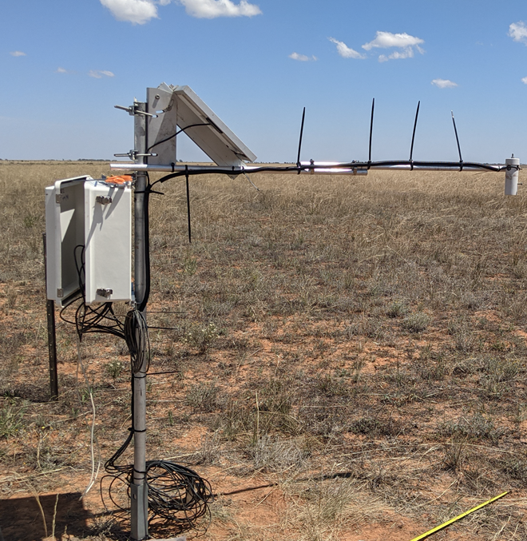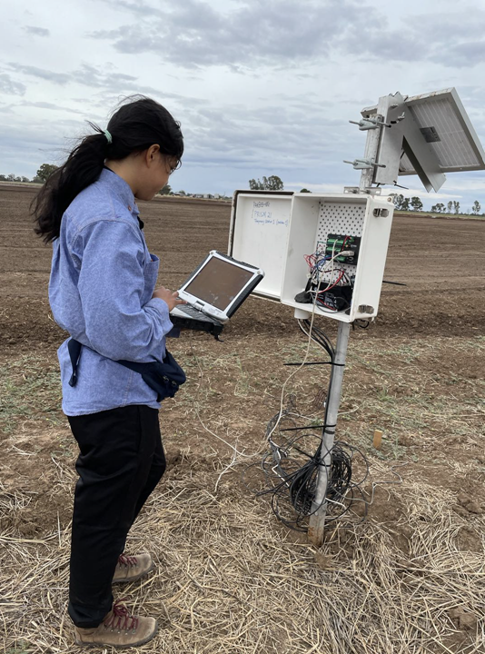
Figure 4-1. Temporary stations during PRISM-2021

GROUND SOIL MOISTURE SAMPLING
The ground soil moisture sampling schedule and covering areas/lines were changed due to raining events and farming activities. Table 5-1 lists the updated schedule of sampling, cover area, team, corresponding flight, and Issues/notes. Figure 5-1 shows the soil moisture sampling points and lines during the field campaign. As shown in Figure 5-1, cotton paddock (ID: F3) was included for soil moisture sampling in order to cover more types of vegetation. Due to the furrow surface condition, nine sampling points were conducted for each sampling location (3 at top, 3 at middle and 3 at bottom) to capture the variation of wetness in the cotton field. The same protocol was applied to the bench bare soil (ID: F6b, F6d & F16) and cotton fields (ID: F6c & F15).

Table 5-1. Soil moisture sampling schedule during PRISM-2021
Date | Teams and Areas | Flight | Issue/Notes
0803 | Team A: F3 (bottom half), F5a, F5b, F6b, F6c, F6d, &F25  Team B: YE | F1-MA | F4 not accessible due to farming activity; F3 top half irrigated
1003 | Team A: F3, F4, F5a, F5b, F6b, F6c, F6d, &F25  Team B: F15 & F16 | F3-MA | More irrigation in F3; YE area too wet to get in
1203 | Team A: F4, F5a, F5b, F6a, F6b, F6c, F6d, &F25  Team B: YE | F5-MA | Heavy rain on 1103. No sampling in F3 due to flooded area by irrigation and rain
1503 | Team A: F4, F5a, F5b, F6a, F6b, F6c, F6d, &F25  Team B: YE | F6-MA | F5a started irrigating from eastern end.
1703 | Team A: F4, F5b, F6a, F6b, F6c, F6d, &F25  Team B: YE | F8-MA | F3 too wet to get in; no access to F5a due to ponding water by irrigation; F6c corn harvest started but not finished, only harvested 1/3.
1903 | Team A: F4, F6a, F6b, F6c, F6d, &F25  Team B: YE | F10-MA | F3 too wet to get in; F6c corn field only done one line due to shortness of participants; F5a ponding water, F5b machinery working on farm.
2303 | Team A and Team B: F25 | F11-MA | Only checking surface condition after heavy rain, most paddocks were with ponding water and hardly get in; only done sampling in F25.
2403 | Team A: F4, F5b, F6a, F6b, F6c, F6d, & F25  Team B: F15 & F16 | F12-MA | F3 cotton too wet to get in; F5a with ponding water due to irrigation and heavy rain
2603 | Team A: F4, F5b, F6a, F6b, F6c, F6d, & F25  Team B: YE | F14-MA | No access to F3 due to more irrigation; no access to F5a due to ponding water

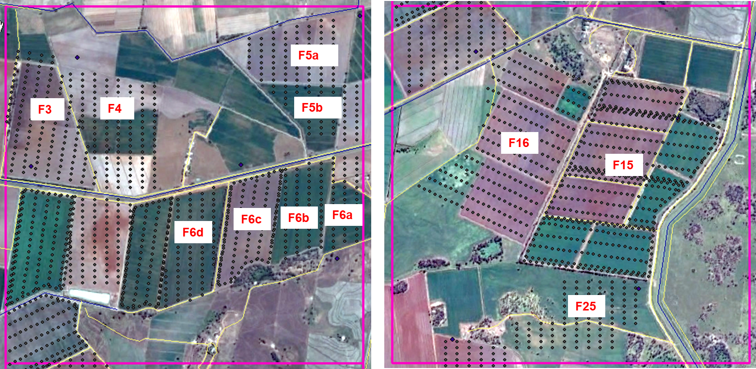Figure 5-1. Soil moisture sampling points in YA area during PRISM-2021, with paddock ID also included.

SCOUT SAMPLING
The SCOUT soil moisture sampling schedule was modified from that outlined in the workplan taking into account the predominant vegetation and roughness types present in the experiment site during PRISM-2021. The updated schedule and covering area are shown in Table 6-1.
Table 6-1. SCOUT sampling schedule (Paddock ID refers to Figure 5-1)
Date | Paddock ID | Pin length (cm) | Nr. Measurement at each location | Note
0903 | F6a, F6b, F6c | 3.5, 5, 12, 20 | F6b, F6c (3 measurements *4 different pins)  F6a (1 measurement *4 different pins) | A few scouts points in F3 cotton field
1303 | F6a, F6b, F6c, F6d | 3.5, 5, 12, 20 | F6b, F6c, F6d (3 measurements *4 different pins)  F6a (1 measurement *4 different pins)
1603 | F6a, F6b, F6c, F6d | 3.5, 5, 12, 20 | F6b, F6c, F6d (3 measurements *4 different pins)  F6a (1 measurement *4 different pins)
1803 | F6a, F6b, F6c, F6d | 3.5, 5, 12, 20 | F6b, F6c, F6d (3 measurements *4 different pins)  F6a (1 measurement *4 different pins) | Due to harvesting the corn and rain fall, half of the points in one line was sampled in F6c.
2003 | F6a, F6b, F6c, F6d | 3.5, 5, 12, 20 | F6b, F6c, F6d (3 measurements *4 different pins)  F6a (1 measurement *4 different pins)
2503 | F6a, F6b, F6c, F3 | 3.5, 5, 12, 20 | F6b, F6c, F3 (3 measurements *4 different pins)  F6a (1 measurement *4 different pins) | Half of the points in one line was sampled in F6c cotton field.

ROUGHNESS SAMPLING
Roughness samplings were conducted on each MR radar flight day. A summary of the schedule for surface roughness sampling is provided in Table 7-1. Note that each measurement comprised two 3m-long profiles, one oriented along the row and the other across row (with clear row structure), or one oriented East-West and the other North-South (no obvious row structure).
Table 7-1. Summary of surface roughness sampling during PRISM-2021 (Paddock ID refers to Figure 5-1)
Date | Paddock ID | Land cover | Type of profiler | Nr. points | Note (Issue)
0903 | F6a | Rough bare | Old roughness pin profiler | 3 | New laser-pin profiler had cable connection issue thus only the old profiler could be used.
 | F6b | Bench bare |  | 3
 | F6c | Corn |  | 3
 | F3 | Cotton |  | 3
 | F5a | Flat bare |  | 3
 | F5b | Stubble bare |  | 3
 | YE | Grass |  | 3
1303 | F6c | Corn | New laser-pin profiler | 3
 | F6d | Bench bare |  | 3
 | F4 | Rough bare |  | 3
 | F5b | Stubble bare |  | 3
 | F6a | Rough bare |  | 3
 | F15 | Corn |  | 3
 | F16 | Bench bare |  | 3
1603 | F6c | Corn | New laser-pin profiler | 3
 | F6d | Bench bare |  | 3
 | F4 | Rough bare |  | 3
 | F5b | Stubble bare |  | 3
 | F6a | Rough bare |  | 3
1803 | F6c | Corn | New laser-pin profiler | 3
 | F6d | Bench bare |  | 3
 | YE | Grass |  | 3
1903 | YE | Grass | Old roughness pin profiler | 3
2003 | F6a | Rough bare | New laser-pin profiler | 3 | F6c corn all harvested, only half leg tall stubble left; profiler pins distorted, therefore a calibration scan was performed on a flat surface. Pins adjusted after that.
 | F6b | Bench bare |  | 3
 | F6c | Corn stubble |  | 3
 | F4 | Rough bare |  | 3
 | F5b | Stubble bare |  | 3
 | F5a | Flat bare |  | 3
 | F16 | Bench bare |  | 3
 | F15 | Corn |  | 3
2503 | F6c | Corn stubble | New laser-pin profiler | 3 | Profiler not working from F3 cotton, USB cable was not recognized by laptop
 | F6b | Bench bare |  | 3
 | F3 | Cotton |  | 3

VEGETATION SAMPLING AND INTENSIVE VEGETATION SAMPLING
Vegetation sampling and intensive vegetation sampling were conducted on each MR radar flight day. The sampling schedule was modified from that outlined in the workplan due to the weather condition, accessibility of the farm, machinery work and etc. The resulting schedule is shown in Table 8-1 including the date, paddock, coordinates, vegetation type, measurements and notes (explaining unexpected farming activities and weather condition).
Table 8-1. Summary of vegetation sampling during PRISM-2021 (Paddock ID refers to Figure 5-1)
Date | Paddock ID | Coordinates  (UTM) | Veg type | Measurements | Note (Issue)
0903 | F6c | 417541.3; 6158389.8 | Corn | 1x destructive  3 x cropscan  1x intensive | LAI not used
 |  | 417536.2; 6158372.1
 | F3 | 415421.8; 6158481.7 | Cotton | 1x destructive  3 x cropscan  1x intensive | LAI not used
 |  | 415424.1; 6158470
1103 |  |  |  |  | No sampling due to rain
1303 | F6c | 417504.7; 6158380.7 | Corn | 1x destructive  1 x LAI  3 x cropscan  1x intensive
 | F6c | 417548.6; 6158384.2
 | F6c | 417412.1; 6157620.3
 | F6c | 417417.6; 6157620.4
 | F15 | -34.7430243; 146.089614
 | F15 | -34.740217; 146.089507
 | F15 | -34.740048; 146.089671
16/03 | F6c | 417525; 6158381 | Corn | 1x destructive  1 x LAI  3 x cropscan  1x intensive
 | F6c | 427498.1; 6158368.6
 | F6c | 417466.6; 6158358.8
 | F6c | 417406; 6157623.7
 | F3 | 415172.5; 6158412.2 | Cotton | 1x destructive  1 x LAI  3 x cropscan  1x intensive
 | F3 | 415166.3; 6158425.9
 | F3 | 415175.7; 6158434
 | F3 | 415177.3; 6158446.5
18/03 | F15 | 416668.9; 6155411.1 | Corn | 1x destructive  1 x LAI  3 x cropscan  1x intensive
 | F15 | 416681.1; 6155422.2
 | F15 | 416659.2; 6155379.6
 | F15 | 416650; 6155364.8
 | YE | 418440.9; 6140858.4 | Grass | 1x destructive  1 x LAI  3 x cropscan
20/03 | F3 | 415170.7; 6168410.4 | Cotton | 1x destructive  1 x LAI  3 x cropscan  1x intensive | F6c corn harvested and only stubble left
 | F3 | 415175.9; 6158435.9
 | F6c | 417300.7; 6158324.3 | Corn stubble | 1x destructive  1 x LAI  3 x cropscan
 | F6c | 417318.8; 6158340
25/03 | F6c | 417520; 6158373 | Corn stubble | 1x destructive  1 x LAI  3 x cropscan
 | F6c | 417520; 6158373
 | F3 | 415177.7; 6158389.1 | Cotton | 1x destructive  1 x LAI  3 x cropscan  1x intensive
 | F3 | 415171.9; 6158437
 | F15 | 417653.2; 6155264.6 | Corn | 1x destructive  1 x LAI  3 x cropscan  1x intensive
 | F15 | 417646.7; 6155250.9

SAMPLE PROCESSING IN LAB
Temperature setting for soil and vegetation samples: 105° for soil samples, and 60° for vegetation samples.
Drying in the oven: at least two days for soil samples, and six days for vegetation sampling. This was decided after continuous measurements on the samples until the weight did not change any more.

LAKE SAMPLING
Lake sampling was performed on 06/03, 13/03, 20/03 and 25/03. There were only few points on 20/03 due to strong wind and wave.

ATTACHMENT-FLIGHT NOTEBOOK

